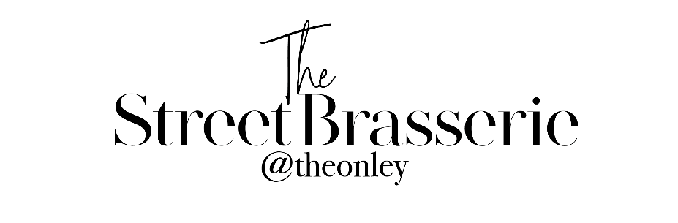

Toast & Jam/Marmalade £3

Eggs Your Way £5
Choice of Scrambled, Fried, Or Poached Eggs on Toast.

Full English £10.50
Smoked Bacon, Butchers Sausages, Black Pudding, Tomato, Mushroom, Hashbrowns, Baked Beans, Fried Hen’s Eggs, Toast.
Small Full English £7.50

Vegetarian Breakfast £9.50
Smashed Avocado, Mushroom, Tomatoes, Hashbrowns, Baked Beans, Fried Hen’s Eggs, Toast.
Small Vegetarian Breakfast £6.50

Smoked Salmon & Scrambled Eggs on Toast £8.00

Smashed Avocado & Poached Eggs on Toast £8.00

Breakfast Sandwich £6.00
Choice of Bacon, Sausage & Vegetarian Sausage.
Extras £2.00
Sausages, Bacon, Hashbrowns, Mushroom, Tomato, Black Pudding, Eggs, Baked Beans
& Toast (White & Granary)

