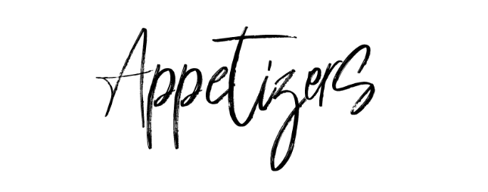

Mixed Olive Bowl £4 (GF)

Sharing Slate
Sourdough, Homemade Wild Garlic Butter, Marinated Olives & Hummus £9 (GFO)

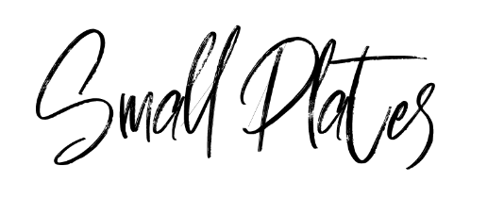

Pate
Chicken Liver Pate, Spiced Plum Chutney & Toast £6 (GFO)

Chicken Piri Piri Skewers
Piri Piri Sauce & Rocket £7.50 (GF)

Tomato & Red Pepper Soup
Cream, Basil & White Sourdough £6 (V)

Prawn Cocktail
Prawn Cocktail, Crevettes, Baby Leaf Salad & Granary Bread £7.50 (GFO)
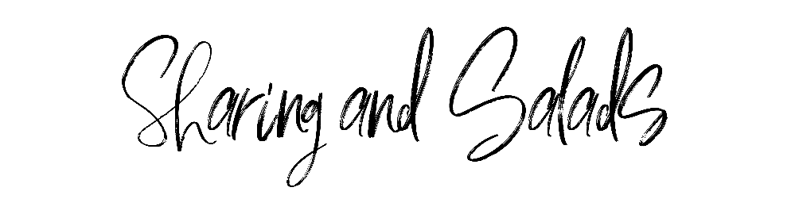

Seafood Slate
Mini Prawn Cocktail, Smoked Mackerel, Crevettes, Smoked Salmon, Dips & Breads £19.5 (GFO)
Add Scampi or Calamari: £4

Camembert
Toasted Sourdough, Baby Leaf Salad & Chutney £10.5 (GFO)

White Bean & Rocket
Cannellini Beans, Rocket, Sun Blushed Tomatoes & Black Olives £13 (VE) (GF)

Piri Piri Chicken Salad
Piri Piri Chicken Skewers, House Salad & Coleslaw £15 (GF)

Rough Cut Chips -Onion Rings- House Salad- Vegetable Medley- Coleslaw-Garlic Bread £4

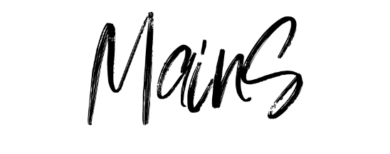

Beer Battered Haddock
Rough Cut Chips, House Tartare, Marrowfat Mushy Peas £15

Whitby Wholetail Scampi
Rough Cut Chips, Baby Leaf Salad & House Tartare Sauce £13

Ox Cheek Ragu
Pappardelle Pasta, Parmesan, Rocket & Garlic Bread £16.50 (GFO)

Fish Pie
Creamy Mash Potato, Applewood Smoked Cheddar, Vegetable Medley £15

Local Pork Sausages or Vegetarian Sausages
Garlic Mash, Vegetable Medley, Slow Roasted Onion & Proper Gravy £14.50

8oz Sirloin Steak
Rough Cut Chips, Crispy Onion Rings, House Salad, Slow Roasted Tomato, Mushroom & Confit Garlic Butter £19.50 (GFO)
Add a Sauce: Peppercorn £2

All Our Burgers Are Served In A Brioche Bun With Salad, Rough Cut Chips & Coleslaw

Brasserie Burger
Two Local Beef Burgers, Monetary Jack Cheese, Homemade Smokey Bacon Jam & Onion Rings £17

Lime & Chicken Burger
Gridled Lime & Chilli Chicken, Guacamole £16.5

Moving Mountains Burger
Monetary Jack Cheese, Mayonnaise £16 (VE)

