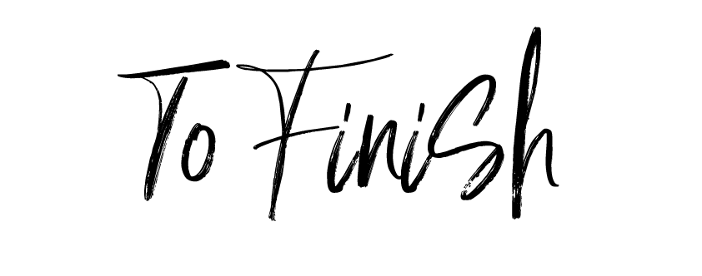

Apple & Cinamon Crumble
Oat Crumble Topping, Choice of Custard or Vanilla Bean Ice Cream £6.95

Chocolate Orange Torte
Vanilla Bean Ice Cream £6.95

Vegan Chocolate Mocha Loaf
Vegan Ice Cream (VE) £6.95

Sticky Toffee Pudding
Buttery Toffee Sauce, Lotus Biscoff Crumb & Simply Ginger Ice Cream or Custard £6.95

Three Scoop “Saffron Walden Ice Cream CO” £4.5
Vanilla Pod, Traditional Chocolate, Strawberries & Cream, Espresso Coffee Bean, Simply Ginger, Salted Butter Caramel, Spiced Essex Rum N Raisin, Henham Honey & Lavender, Mint Chocolate Chip, Mince Pie, Chocolate Orange & Cinnamon Biscuit.

Three Scoop Saffron Walden Ice Cream CO Sorbet £5.5
Apple, Prosecco, Gin & Tonic, Raspberry, Blackcurrant

Cheese Board
Local Cheeses, Pickles, Sundried Tomatoes, Tiptree Honey, Chutney, Crackers £12.5

Add A Glass of Port for: £3

